**EV - Market Geographic Segmentation**

**Abstract**:

This article provides a succinct introduction to the marketing tactic known as market segmentation (MS). Market segmentation is a key tactic that enables companies to recognise and target particular consumer segments with targeted advertising and product offerings. This case study looks at how a retailer increased sales and profitability by using market segmentation. This case study exemplifies how crucial market segmentation is to boosting revenue and profitability. Businesses can maintain their competitiveness and cater to the specific wants and preferences of their customers by recognising and targeting particular consumer groups with customised marketing messages and product offerings. Additionally, it emphasises important MS-related concepts together with their theoretical underpinnings and Python-based applications. One of the economies with the quickest growth is India.

Market Segmentation

**What is Market Segmentation?**

The division of a bigger market into smaller groups of consumers with comparable wants, traits, or behaviours is known as market segmentation. Market segmentation is to recognise and target these particular customer groups with customised advertising messages and product proposals that would better suit their tastes and needs. This enables companies to develop marketing efforts that are more successful and raises the possibility of bringing in and keeping customers. Numerous variables, including demographics, psychographics, location, behavioural patterns, and more, can be used to segment the market.



**Why is it important?**

Market Segmentation is necessary as:

1. Gaining a deeper understanding of clients: By recognising their unique demands, preferences, and behaviours, market segmentation enables firms to better understand their customers. Due to their ability to better address these needs, firms are able to personalise their marketing messaging and product offerings, which eventually results in more satisfied and devoted customers.
2. Marketing campaigns can be made to be more effective by targeting particular consumer segments with messaging and product offerings that are more appropriate for them. Better engagement, higher response rates, and higher sales result from this.
3. Competitive advantage: By developing products and marketing messages that are more suited to the requirements and preferences of particular consumer groups, firms can set themselves apart from their rivals. This gives firms a competitive edge and allows them to stand out in a crowded market.
4. Targeting particular consumer groups allows businesses to make more effective use of their marketing resources. Businesses can concentrate their resources on marketing strategies that are more likely to resonate with particular customer groups rather than investing money on campaigns that target a broad audience.

**Types of Market Segmentation**

There are different types of market segments that you can create. The four major types of Market Segmentation are given below.

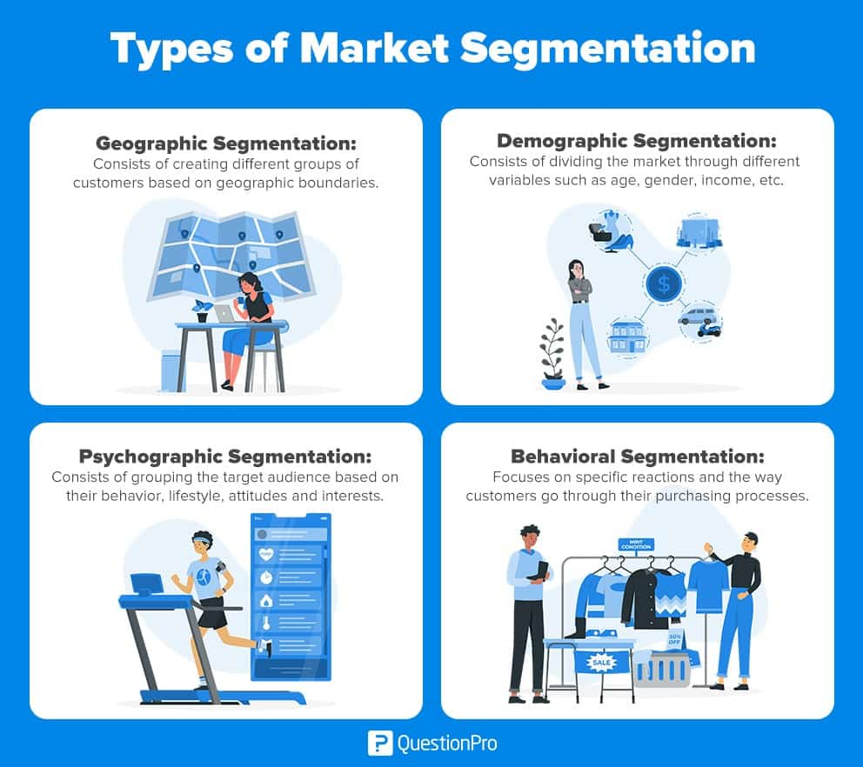

**Fig**: Methods of Market Segmentation

**Geographic Segmentation**

Segmenting the market according to a given geographic area, such as a nation, region, city, or climate. Your target segment is divided up using geographic segmentation based on places like a country, state, etc. Customers can also be located by taking into account their location's features, such as their language and if they live in an urban, suburban, or rural environment.



Urban/Rural

Language

Time Zone

Location

Climate &

Season

Geographic

Segmentation

**Fig**: Geographic Segmentation.

**Market Segmentation:**

The EV market in India can be segmented based on geography into North India, South India, East India, and West India.

**North India:** Major cities like Delhi, Noida, and Gurgaon are at the forefront of the adoption of electric vehicles, making North India one of the top regions in the Indian EV industry. Due to rising public knowledge of the advantages of electric vehicles and government incentives to support clean energy, there is a considerable demand for electric two-wheelers and three-wheelers in the region. The Delhi government has unveiled a thorough electric car strategy, providing incentives like road tax and registration fee deductions for electric vehicles.

**South India**: With cities like Bangalore, Hyderabad, and Chennai spearheading the adoption of electric vehicles, South India is another important market for electric vehicles. Because there are many IT companies in the area and a developing middle class, there is a significant demand for electric vehicles. The Karnataka state government has unveiled a comprehensive electric vehicle strategy that includes incentives for electric vehicles, including exemptions from road tax, registration fees, and electricity rates.

**East India:** Although the industry for electric vehicles in East India is still relatively young, it has a lot of growth potential in the years to come. Due to government attempts to support clean energy and growing knowledge of the advantages of electric vehicles, cities like Kolkata and Bhubaneswar have seen an increase in demand for them. A complete electric vehicle strategy has been unveiled by the West Bengali administration, offering incentives like a road tax, registration fee, and electricity tariff exemption for electric vehicles.

**West India:** With cities like Mumbai, Pune, and Ahmedabad spearheading the adoption of electric vehicles, West India is another important market for electric vehicles. Due to the presence of major auto manufacturing enterprises and a growing middle class, the area has a significant demand for electric vehicles. A comprehensive electric vehicle strategy has been unveiled by the Maharashtra government, including incentives like reduced electricity rates, road tax exemptions, and registration fees.

**Algorithm used in this project:**

**K-means clustering**: is an unsupervised machine learning algorithm that is used to group data into K clusters based on their similarity. It is a simple and efficient algorithm that is widely used in various applications such as market segmentation, image segmentation, and data mining.

The basic idea behind the K-means algorithm is to minimize the distance between the data points and their respective cluster centroids. The algorithm starts by randomly selecting K initial cluster centroids from the data set. Then, each data point is assigned to the closest centroid based on the Euclidean distance between the data point and the centroid. Once all data points are assigned to their respective clusters, the centroid of each cluster is updated as the mean of all the data points in that cluster. The process of assigning data points to clusters and updating the centroids is repeated until the centroids no longer move or the maximum number of iterations is reached.

The K-means algorithm has a few key parameters:

1. K: The number of clusters to be formed. This is typically chosen based on prior knowledge or experimentation.
2. Distance Metric: The distance metric used to measure the similarity between the data points and centroids. Euclidean distance is the most commonly used distance metric, but other distance metrics such as Manhattan distance and cosine similarity can also be used.
3. Initialization Method: The method used to select the initial K centroids. Random initialization is commonly used, but other methods such as k-means++ initialization can also be used to improve the quality of the clustering.

The K-means algorithm has a few advantages:

1. Simple and easy to implement.
2. Fast and efficient for large data sets.
3. Can handle high-dimensional data.

However, it also has some limitations:

1. The algorithm is sensitive to the initial centroid selection.
2. The algorithm may converge to a local optimum, rather than the global optimum.
3. The algorithm may not work well with non-linear data.

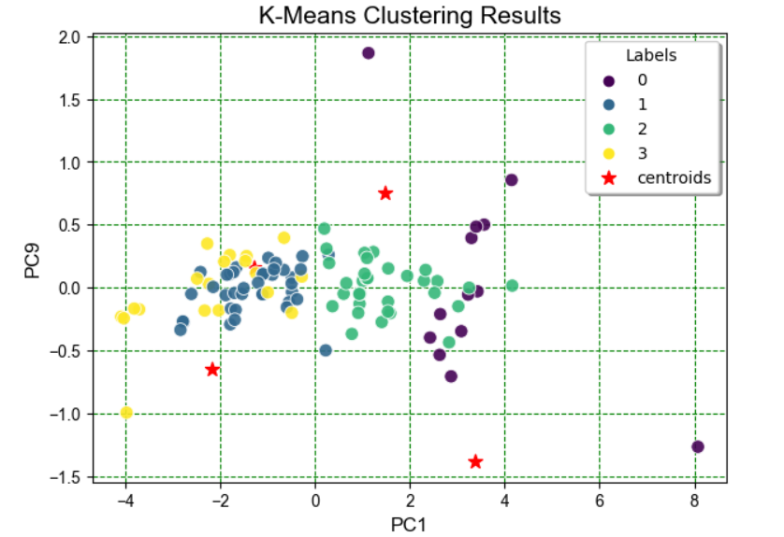

**Conclusion:**

In conclusion, India's market for electric vehicles is expanding significantly as a result of growing government support and increased public understanding of the advantages of electric vehicles. Geographically speaking, the market is divided into North India, South India, East India, and West India. East India is a relatively new market with significant development potential in the years to come, in contrast to North and South India, which are the country's two largest markets for electric vehicles. The industry is anticipated to develop across all areas as a result of rising consumer awareness, disposable income, and government backing. However, issues like a lack of infrastructure, expensive costs, and range anxiety are likely to slow down the market's growth in the near future. These issues are anticipated to be resolved by the government's actions to support sustainable energy and incentives for the use of electric vehicles, which will also fuel the expansion of the EV industry in India.